**STUDENT MANAGEMENT SYSTEM**

MANUAL

**Developed By:**

* RAJNI KINGRANI [1812130]
* MAHEK DEMBRA [1812117]
* HIRDESH KUMAR [1812114]
* SYED MUSTAFA IMAM [1812134]
* SYED HURRAR HASAN RIZVI [1812135]

Table of Contents

**Background ……………………………………………………………………………………………………………** 4

**Home Screen ……………………………………………………………………………………………………………** 5

**Menu ………………………………………………………………………………………………………………….....** 7

**Add Student Record …………………………………………………………………………………………………..** 8

**Delete Student ………………………………………………………………………………………………………….** 10

**Display Student List ………………………………………………………………………………………………....** 12

**Student Course Registration ………………………………………………………………………………………** 13

**Display Student with all Courses …………………………………………………………………………………** 15

**Search Specific Complete Record ………………………………………………………………………………** 16

**Exit ……………………………………………………………………………………………………………………** 19

**Background**

Student management is vital element of an educational institute. The institute faces serious challenges while handling their student data. The student data comprises of his or her academic and personal information. The aim of this program is to perform the following tasks:

* **Add Student Record**
* **Delete Student Record**
* **Display Student List**
* **Student Course Registration**
* **Display Students with all Courses**
* **Search Specific Complete Record.**

**Home Screen**

When the user will open the program, he will be directed to the home screen.

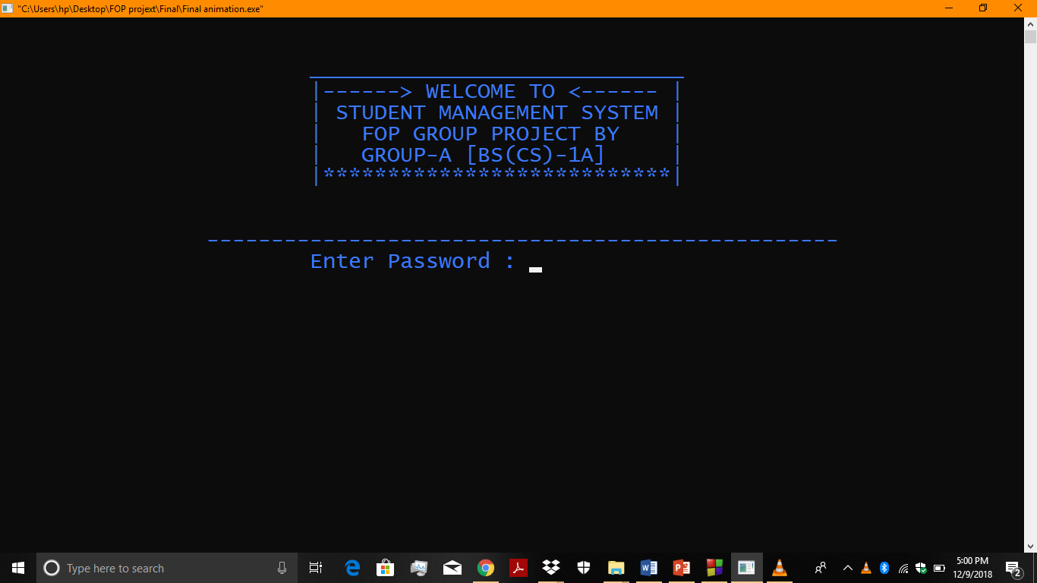

If the user wants to **enter** the **menu**, and types the wrong password the program would notify with incorrect password. An option would be given if the user wants to exit. If user presses (**N or n**), the user will return to home screen. 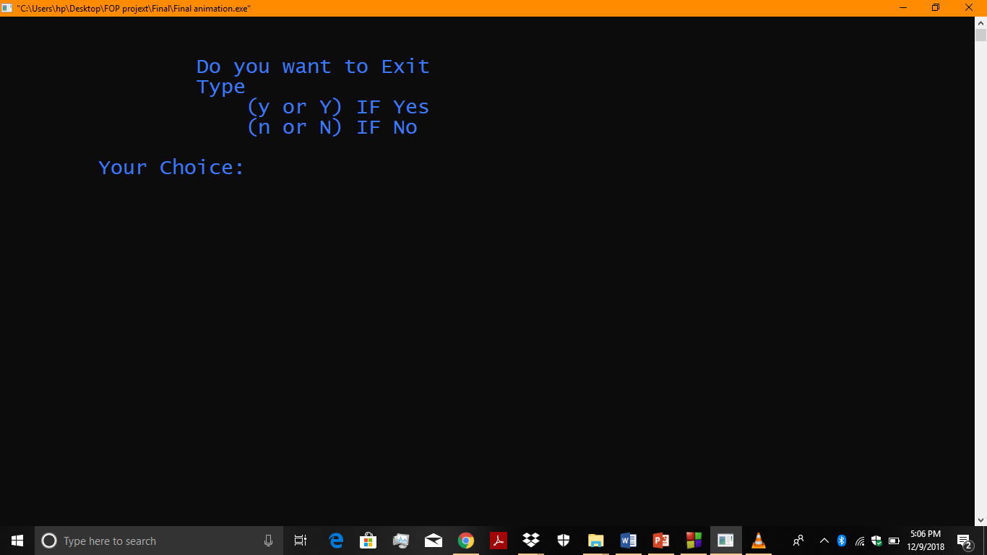

If the user presses (**Y or y**), the user will enter the exit page.

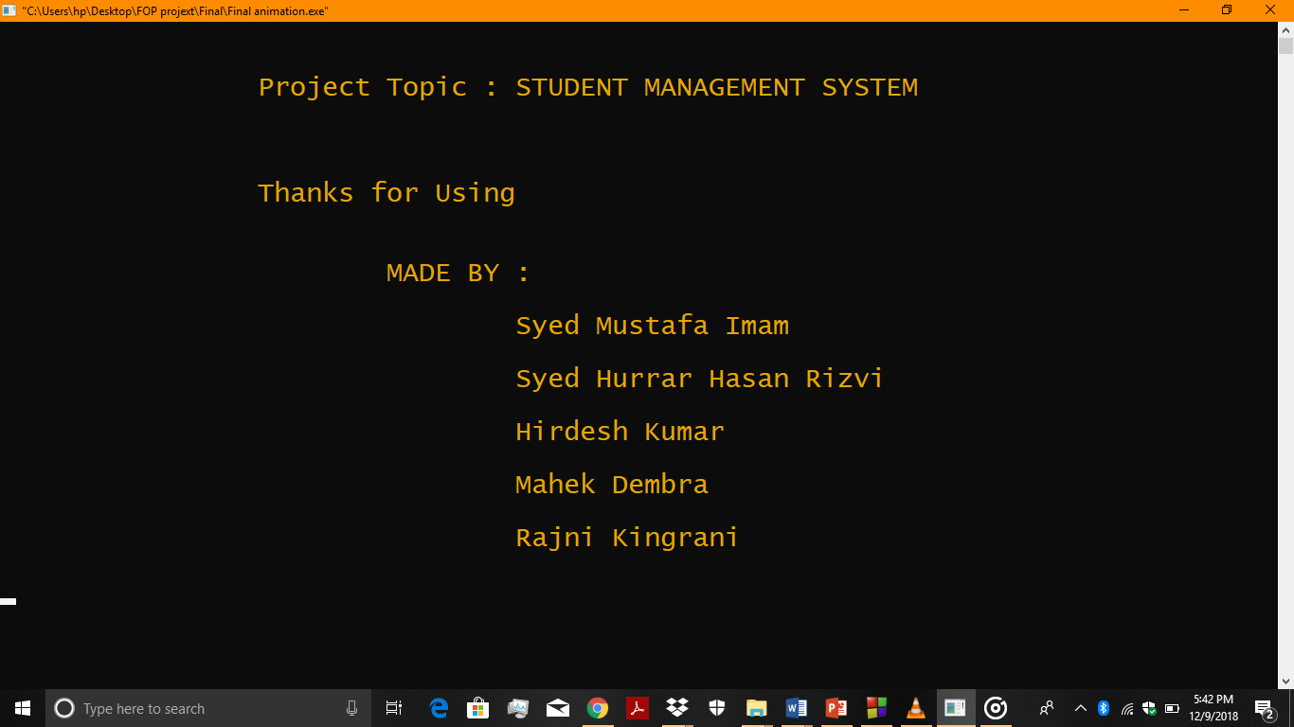

**MENU**

If the user enters the **correct password**, the user will be directed towards the main **menu**.

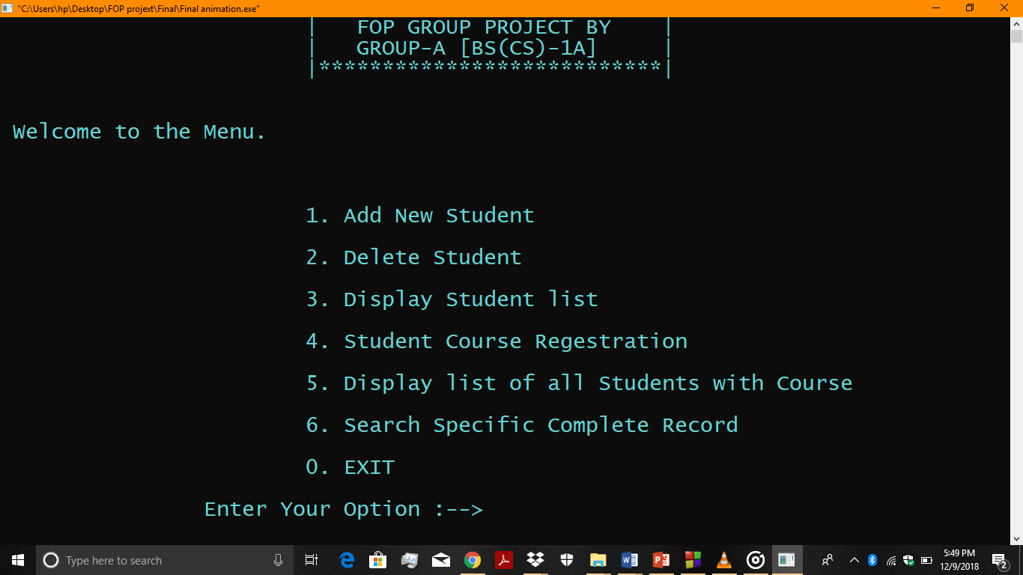

The user would have entered **only one** of the numbers to perform the desired operation.

**Add New Student**

If the user enters **1**, the user will be directed towards **Add New Student function**.

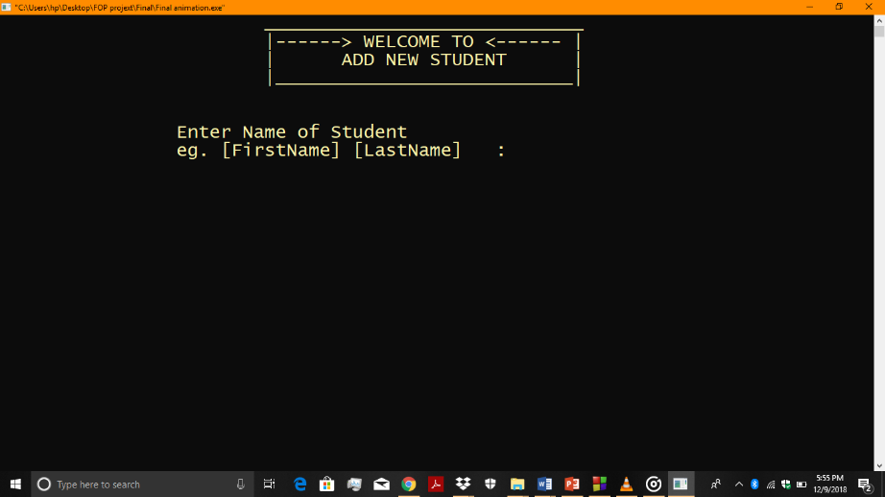

The program would ask the user **First Name, Last Name, Program, Section, Roll Number,** and **Percentage of the last exam** of the student.

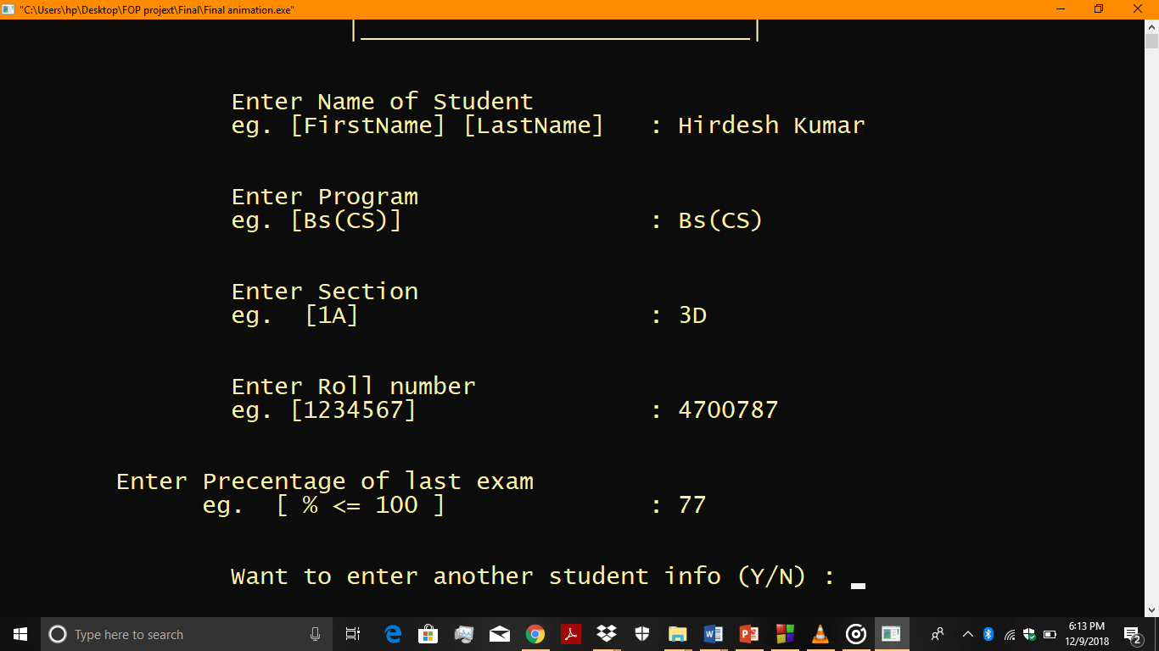

The program would ask from the user to add another student record, then it will give the user two options (**Y or y**) or (**N or n**). If the user presses (**Y or y**), the user can add a student record. If the user presses (**N or n**).

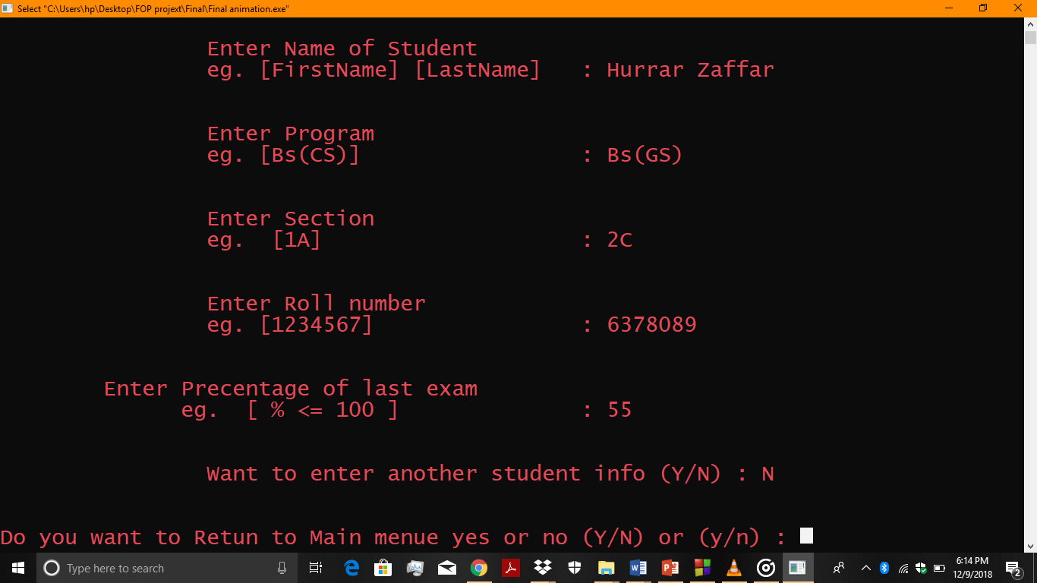

Then, the program would givethe user two options (**Y or y**) or (**N or n**) whether to return to main menu. If the user presses (**Y or y**), the user will return to main menu, then if the user presses (**N or n**), the user exit the program.

**Delete Student**

If the user enters **2**, the user will be directed towards **Delete Student function**.

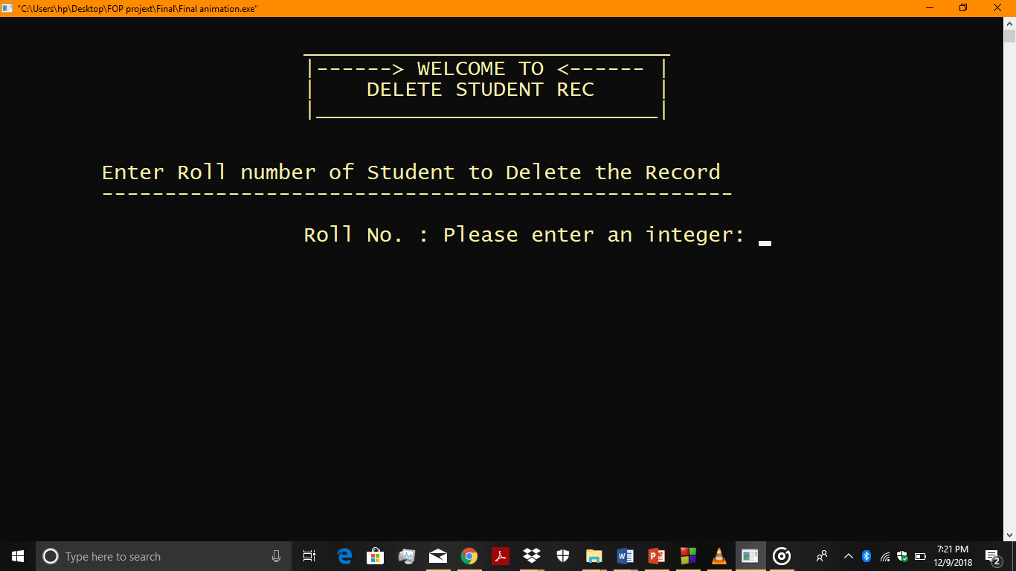

Then, the program would ask from the user for the **Roll Number** of student that the user wants to delete the student record and the input should be **integer** form. And if the enters the roll number that **does exist** in our program records. The program will show!!!!**ERROR RECORD NOT FOUND**

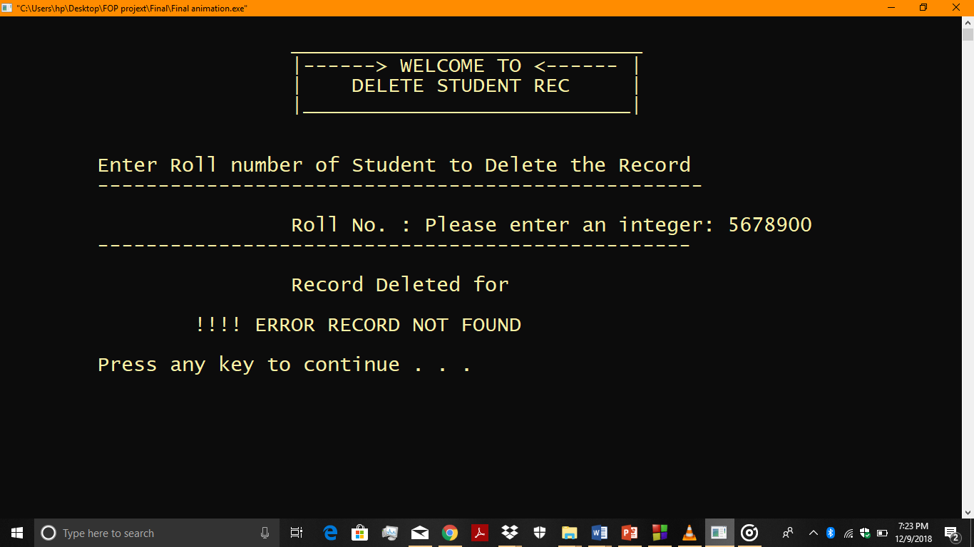

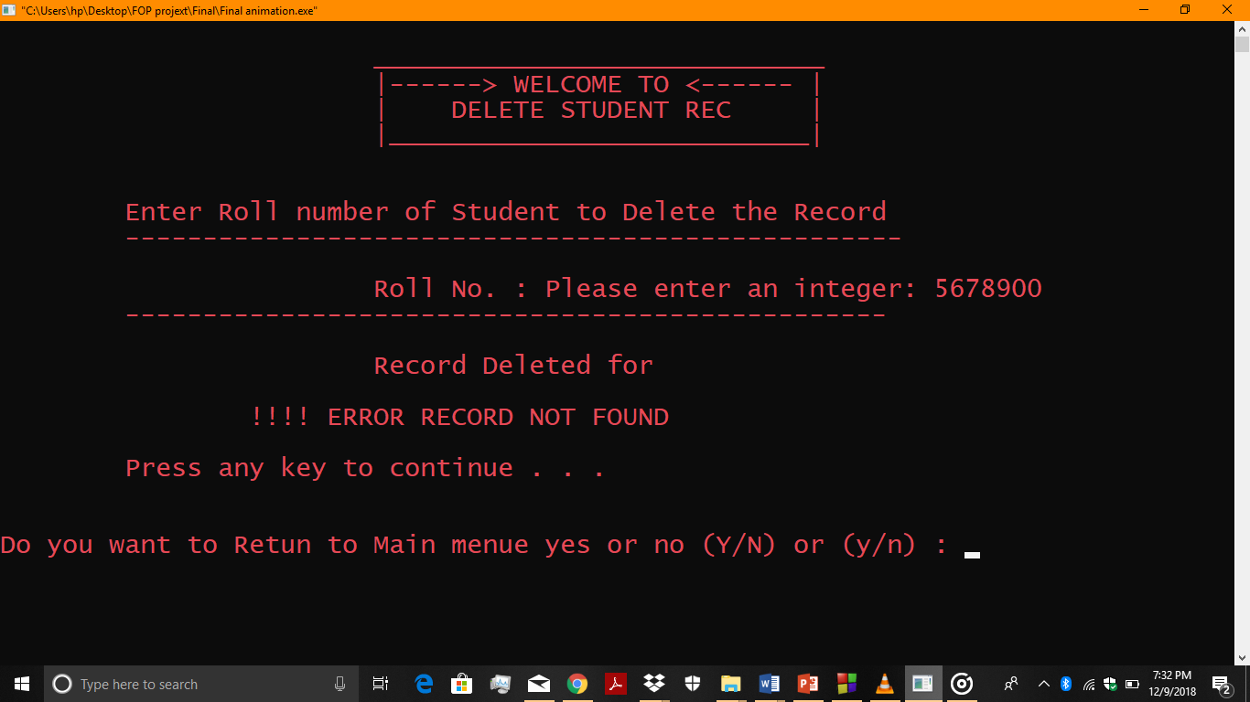

After pressing a key, if the user presses (**Y or y**), the user will return to main menu, then if the user presses (**N or n**), the user will exit the program.

If the user types the correct roll number, the record will successfully be deleted.

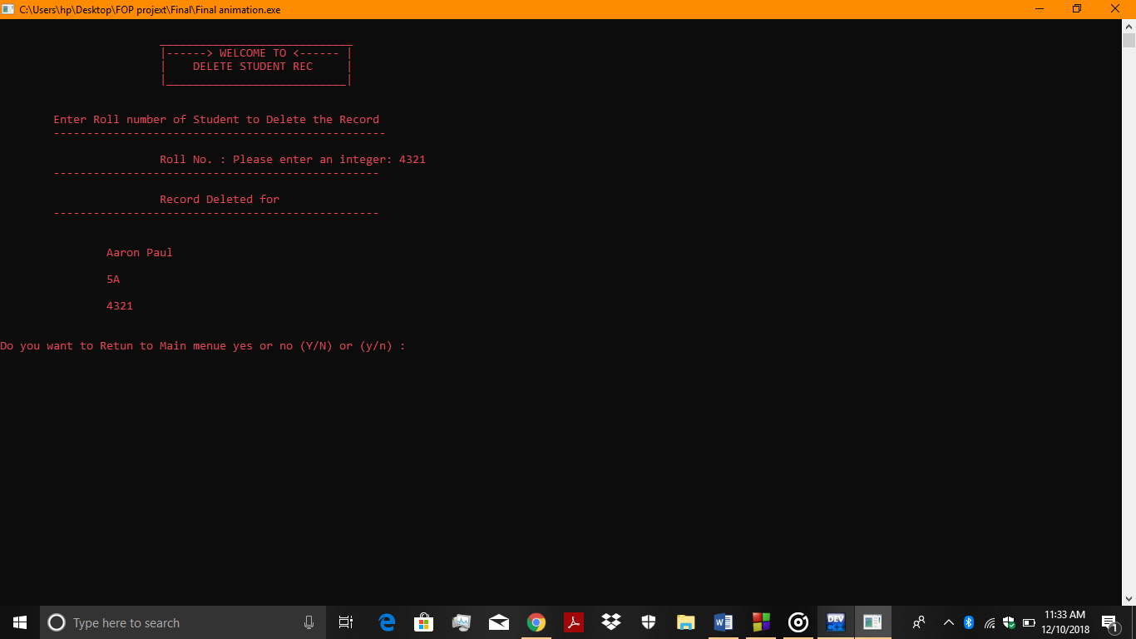

**Display Student List**

If the user enters **3**, the user will enter **Display Student List function.**  Then, the program will show the **data** already present in the system.

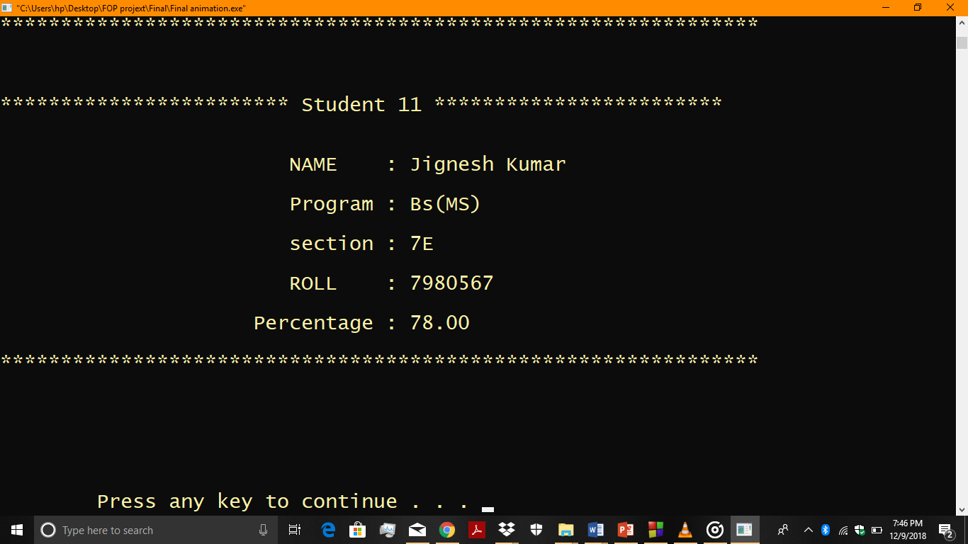

After pressing a key, if the user presses (**Y or y**), the user will return to main menu, then if the user presses (**N or n**), the user will exit the program.

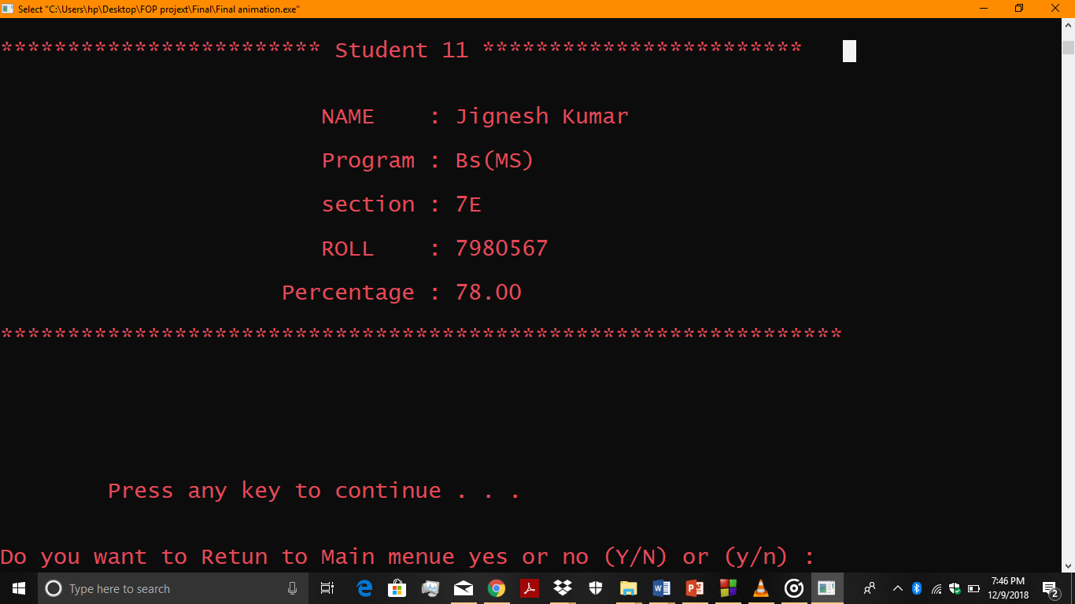

**Student Course Registration**

If the user enters **4**, the **Student Course Registration function.** Then, the program would ask form user the **First Name, Last Name**, **Program**, **Section** and **Roll Number** of the student,

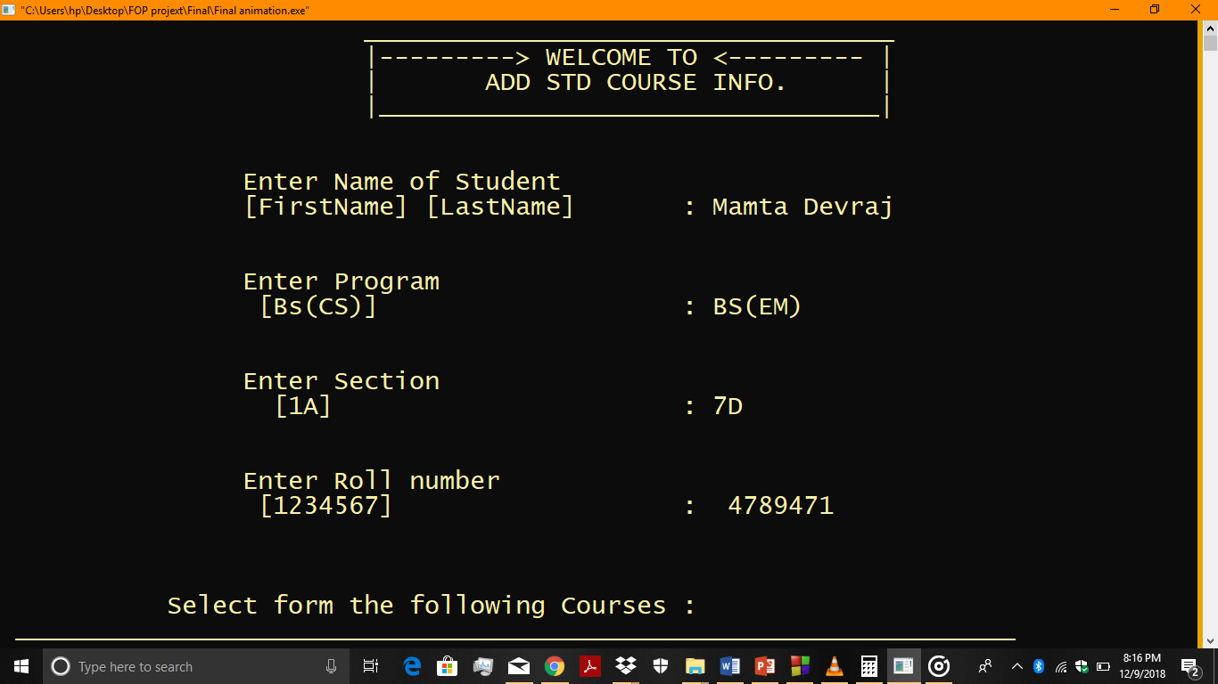

Then, the program will show the **List of Courses (FOP, FOP LAB, Math’s, DLD, ITC, ITC LAB, English, English (OCPS), Applied Physics, and Applied Physics LAB)**. Then, the user will have to **Choose** **8 courses** form the list.

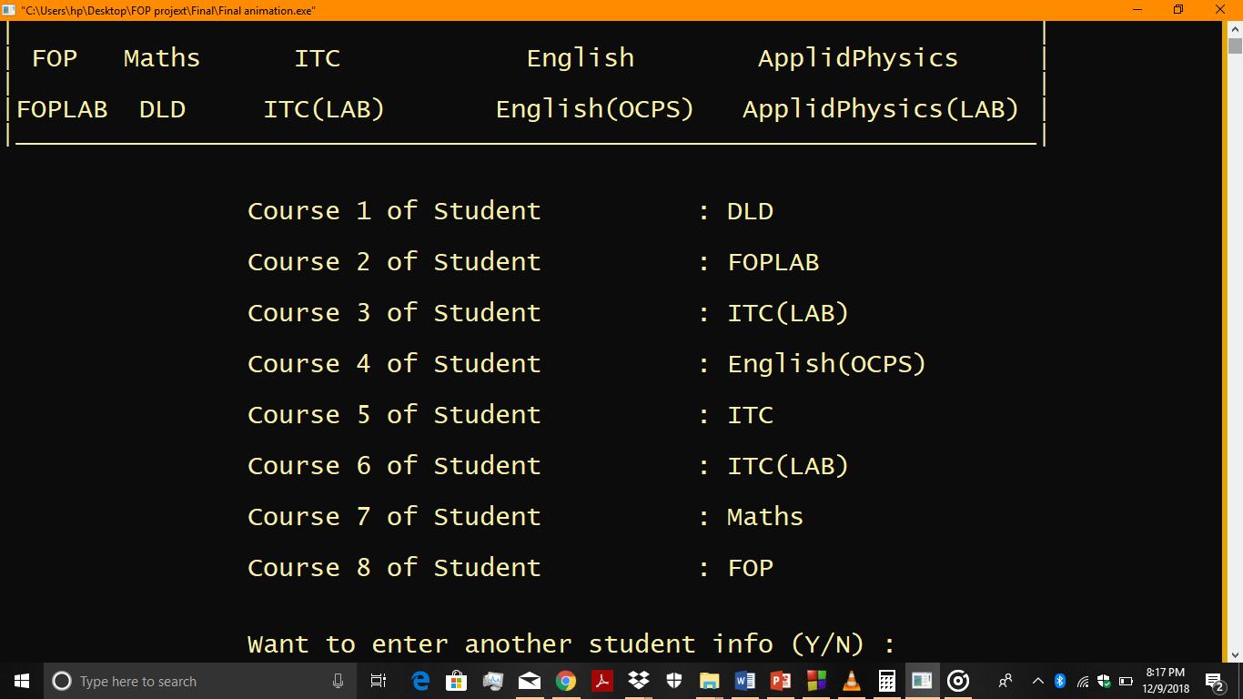

The program would ask from user to add another student record, then it will give us two options (**Y or y**) or (**N or n**). If the user presses (**Y or y**) then, add another student record will appear. If the user presses (**N or n**).

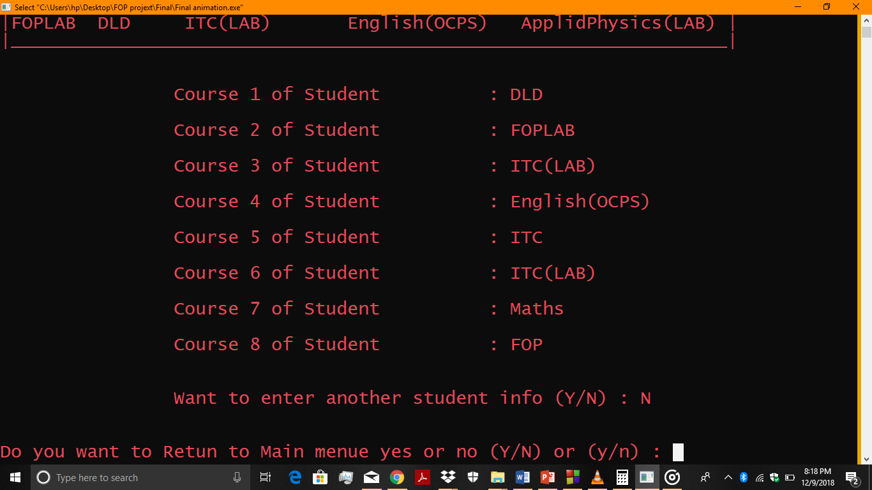

Then, the program would giveus two options (**Y or y**) or (**N or n**) whether to return to main menu. If the user presses (**Y or y**), the user will return to main menu. Then, if the user presses (**N or n**), the user will exit the program.

**Display list of all Students with Course**

If the user enters the **5**, then the program will show the **data** that is already present in **Student Course Registration.**

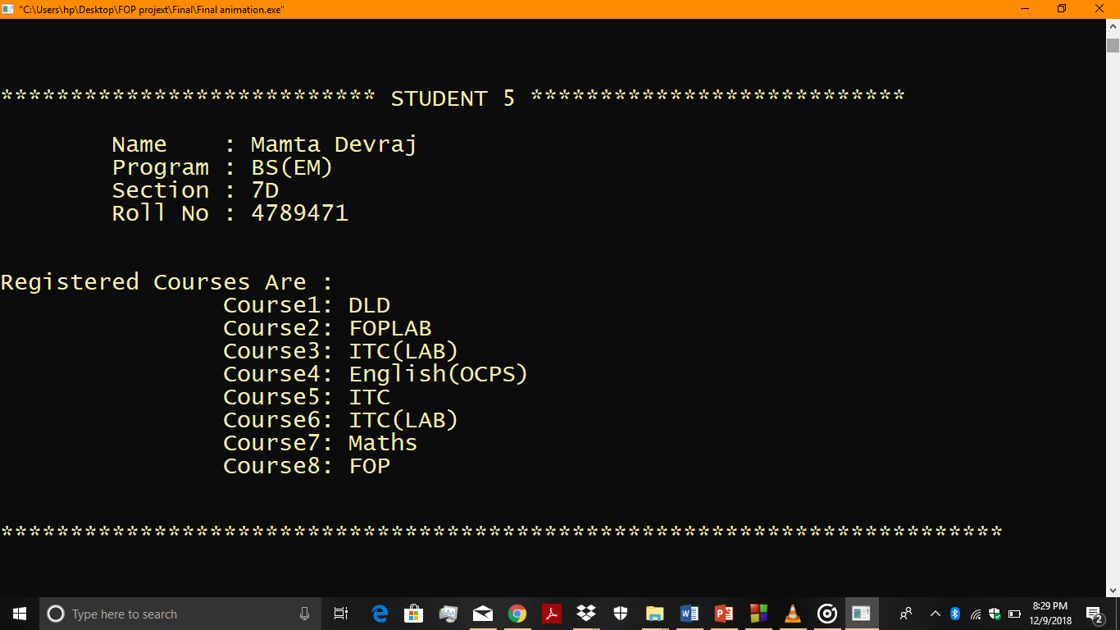

After pressing a key, if the user presses (**Y or y**), the user returns to main menu. Then, if the user presses (**N or n**) the use will exit the program.

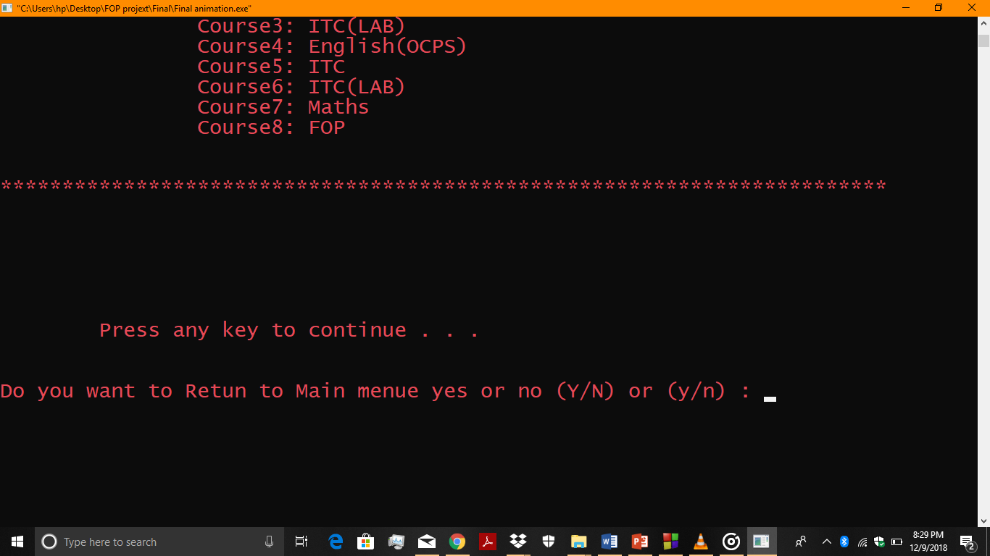

**Search Specific Complete Record**

If the user enters **6**, the user enters **Search Specific Complete Record** function**.**

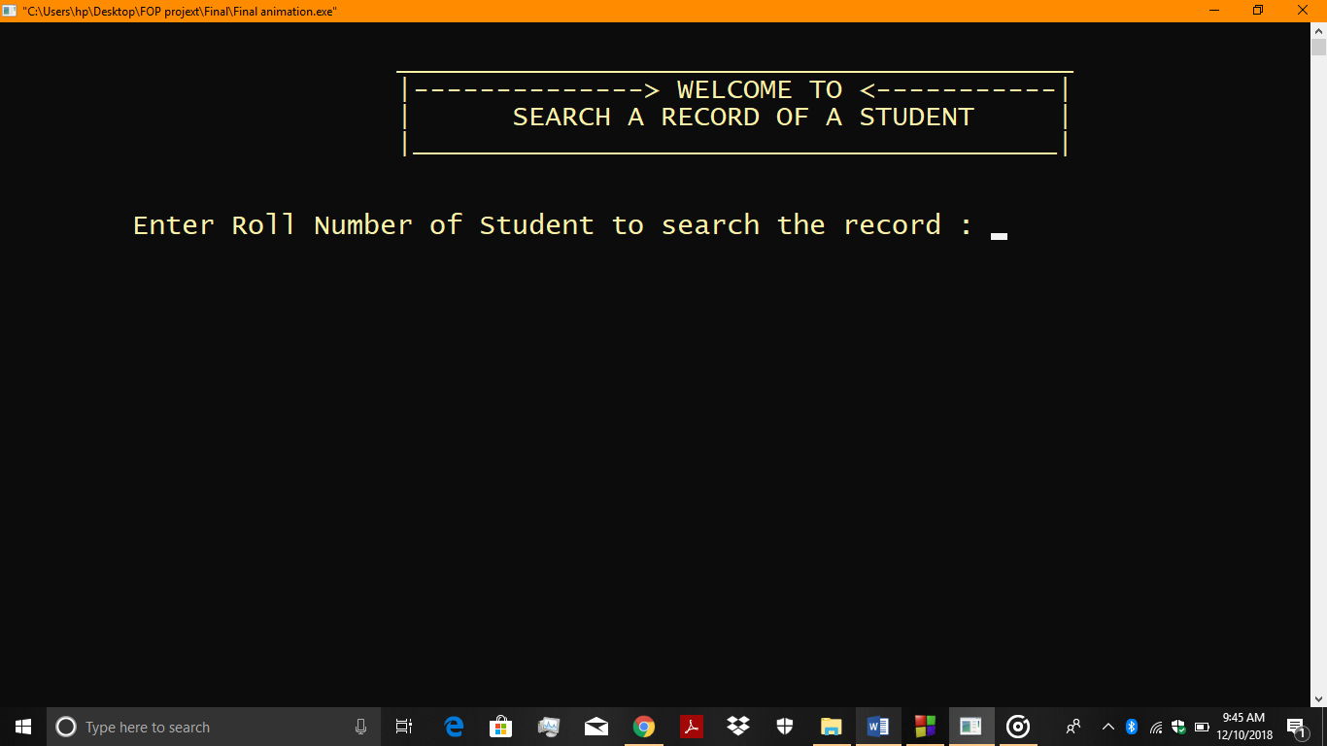

The program will ask the **Roll Number** of the student to search. If the user enters the wrong **Roll Number**, the screen will show!!!!**ERROR RECORD NOT FOUND!!!!**

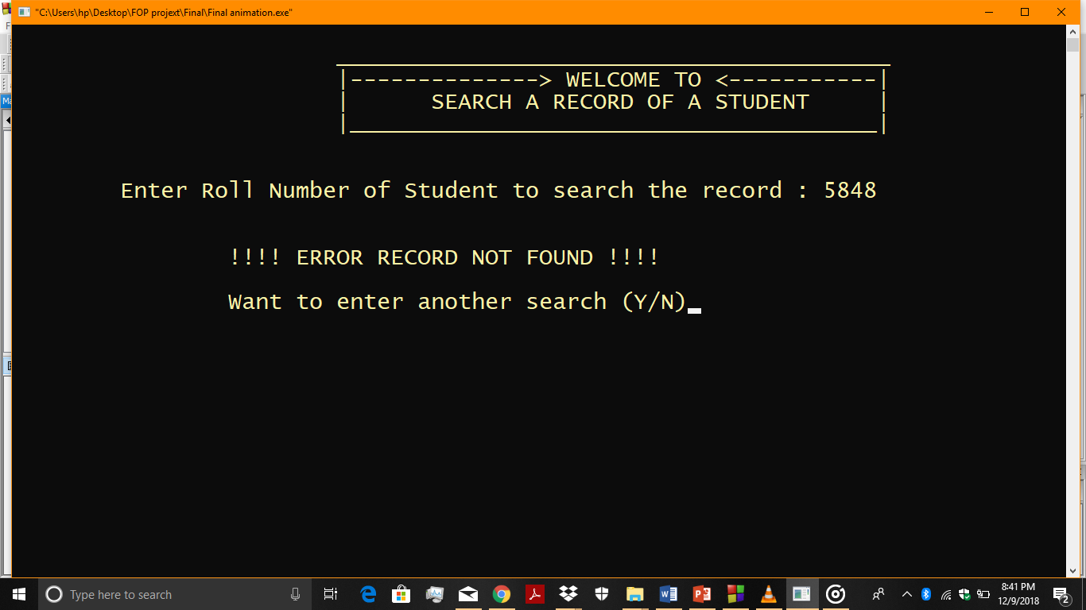

Then, the program would ask the user to do a search record then, it gives us two options whether we want to a search record. If the user presses (**Y or y**), the program will return search for the data feature.

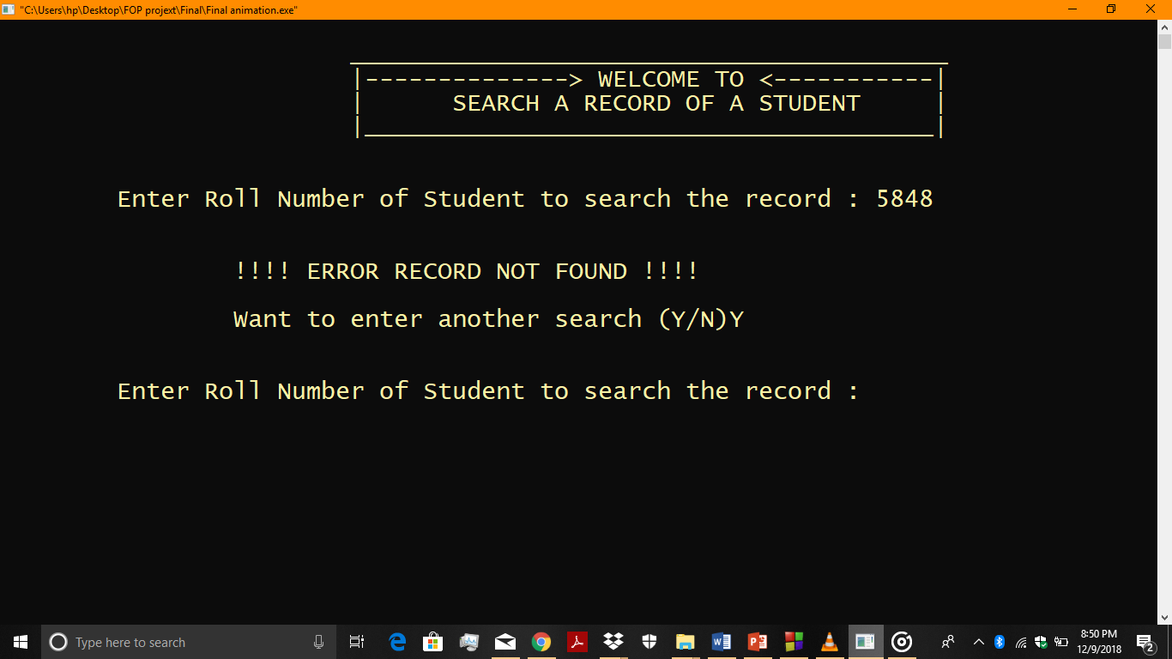

If the user presses (**N or n**), the program would giveus two options (**Y or y**) or (**N or n**) whether to return to main menu. If the user presses (**Y or y**), the user will return to main menu, then if the user presses (**N or n**), the user will exit the program.

If we enter the correct **Roll Number**, the program will display all the courses that the student has registration.

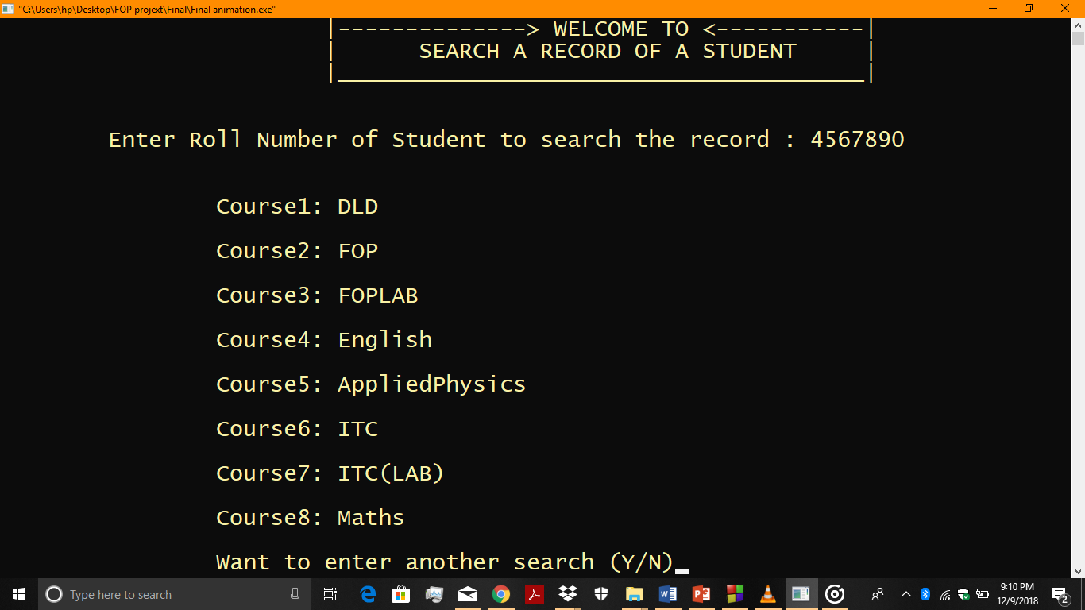

Then, the program asks whether we want to a search another student record. If the user presses (**Y or y**), the program will search for the data. If the user presses (**N or n**), the program would giveus two options.

(**Y or y**) or (**N or n**) whether to return to main menu. If the user presses (**Y or y**), the user will return to main menu. If the user presses (**N or n**), the user exit the program.

**EXIT**

If the user enters the **0**, the user will enter the **EXIT** of the program and user will see the names of students that created the entire program **STUDENT MANAGEMENT SYSTEM.**

